Open Source Software – Evaluated Course Project Final Submission



Chosen Software: Python
Suggested repository name: oss-audit-24BEY10081
Project Title: Open Source Audit – Python
Student Name: Akshansh Srivastava
Registration Number: 24BEY10081
Submission Date: 31 March, 2026

TABLE OF CONTENT:

- Introduction
- Part A – Origin and Philosophy of Python
  - Problem Python Solved
  - Python License
  - Ethics of Open Source
- Part B – Linux Footprint
- Part C – FOSS Ecosystem
- Part D – Open Source vs Proprietary
- Shell Script Outputs
- Conclusion
- References

INTRODUCTION:
- Open-source software is software whose source code is available publicly. This means that anyone can study it, use it, change it, and share it with others. Unlike proprietary software, open-source software is not controlled by only one company. Instead, it is developed by communities of programmers who work together and improve the software over time.
- Open source is important because it gives users freedom. If a program has a bug, developers can inspect the code and fix it. If a feature is missing, they can add it. Because many people contribute together, open-source software often becomes more secure and reliable. Some of the most important technologies in the world are open source, including Linux, Git, Firefox, Apache, and Python.
- For this project, I selected Python because it is one of the most useful and widely used open-source technologies in the modern world. Python is not only a programming language; it is also the foundation of many important applications and technologies. It is simple to learn, easy to read, and powerful enough for professional software development.
- I chose Python because I am preparing for an AI-related career and future interviews. In the field of Artificial Intelligence and Machine Learning, Python is the most commonly used language. Most AI tools, libraries, and frameworks are written in Python. Therefore, understanding Python is directly useful for my future career.
- Python is extremely important in modern technology. It is used in web development, data science, cybersecurity, cloud computing, automation, robotics, and scientific research. Companies such as Google, Netflix, and Instagram use Python in many of their systems.
- Python is especially important in AI because the most popular machine learning frameworks are based on Python. For example, TensorFlow is used for deep learning and neural networks, while PyTorch is widely used in research and modern AI applications. Libraries such as NumPy and Pandas are also written for Python and make data analysis easier.
- Another reason why Python is important is that it is beginner-friendly. A student can learn Python much faster than languages such as C or Java. At the same time, professionals can use the same language for advanced projects. Because of this, Python connects beginners and experts.
- This report studies Python not only as a programming language but also as an open-source project. It explains why Python was created, what license it uses, how it works on Linux, what community supports it, and how it compares with proprietary alternatives.

Part A – Origin and Philosophy of Python
A1. The Problem Python Was Created to Solve
Before Python was created, programming was often difficult and frustrating. Most popular languages in the 1980s, such as C, Pascal, and shell scripting languages, had serious limitations. C was very powerful, but it required complex syntax and many lines of code. Even a simple program could look confusing to beginners. Shell scripts were easier to write, but they were not suitable for building large programs.
Guido van Rossum wanted a language that combined the best qualities of both. He wanted something that was easy to learn like a shell script but powerful enough to build real software. At that time, he was working at the Centrum Wiskunde & Informatica (CWI) in the Netherlands.
Guido had already worked on another programming language called ABC. ABC was simple and easy to read, but it had many practical problems. It could not be extended easily, and it was not useful for large projects. Guido believed that he could build a better language using the good ideas of ABC while removing its weaknesses.
In 1989, he started working on a new language in his free time. He wanted a language with these qualities:
- Simple and readable syntax
- Fewer lines of code
- Ability to run on different operating systems
- Open-source development
- Easy for beginners but useful for experts
The first public version of Python was released in 1991. Guido named it after the comedy group Monty Python because he wanted the language to feel fun and friendly.
Python solved an important problem: programming no longer had to be complicated.
For example, in the C language, a simple "Hello World" program looks like this:
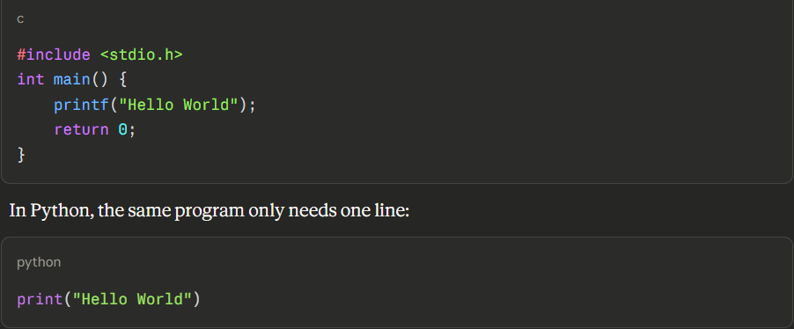
This example shows why Python became so popular. The code is shorter, easier to understand, and easier to remember.
Python was also designed as open-source software from the beginning. Guido did not keep it private or sell it as proprietary software. He believed that a programming language becomes better when many people can improve it together. Because of this decision, thousands of developers around the world contributed to Python.
Today, Python is used in Artificial Intelligence, Machine Learning, Data Science, Web Development, Cybersecurity, and Automation. Without Python, many modern technologies would be much harder to build.
A2: THE PYTHON LICENSE – WHAT IT ACTUALLY SAYS
Python is distributed under the Python Software Foundation (PSF) License. This is an open-source license that gives users a high level of freedom.
The most important idea behind free software is the concept of the "four freedoms." These freedoms explain what users are allowed to do with the software.
The four freedoms are:
- Freedom to run the program for any purpose.
- Freedom to study how the program works.
- Freedom to modify the program.
- Freedom to distribute original or modified versions.
Python provides all four freedoms. Anyone can download Python, inspect its source code, make changes, and share their modified version.
However, Python's license is more permissive than the GNU GPL license. Under the PSF License, a company can take Python, modify it, and sell the modified version without making its changes public. For example, if a company builds a special version of Python for its own software, it is allowed to keep those changes private. This is different from the GPL license. Under GPL, if a company modifies the software and distributes it, it must also release the modified source code.
The difference between GPL and MIT/PSF-style licenses is shown below:
License | Can Modify? | Must Share Changes? | Can Use in Closed Software?
GPL | Yes | Yes | No
MIT | Yes | No | Yes
PSF | Yes | No | Yes

If I created my own project, I would choose the GPL license if I wanted all future versions to remain open-source. I would choose the MIT or PSF license if I wanted companies to adopt my software more easily.
Another important concept is the difference between "free as in free beer" and "free as in freedom."
"Free as in free beer" means the software costs nothing to use or download.
"Free as in freedom" means the user has control over the software — they can study, change, and share it.
Python is free in both senses. It costs nothing to download, but more importantly, it gives users the freedom to understand and change the software. This makes Python one of the purest examples of what open-source software should be.
PART A3: THE ETHICS OF OPEN SOURCE
Open source is not only a technical idea. It is also an ethical idea about how knowledge should be shared.
Some people believe that all software should be open source. Their argument is that software affects millions of people every day. If software is closed, users do not know what the program is doing. Closed software may collect personal data, include security problems, or force users to depend on one company. Open-source software solves this problem because anyone can inspect the code. This makes software more transparent and more trustworthy.
For example, if a company creates an app that collects user data, open-source code allows people to verify exactly what information is being collected and whether it is being shared with third parties.
However, there is also an argument against making every program open source. Some types of software may need to remain private. For example, military systems, banking infrastructure, medical records systems, and private research projects may create security risks if fully opened to the public. Therefore, I believe that not all software must be open source, but software that affects large numbers of people should be as transparent as possible.
Another ethical question is whether it is fair for companies to earn money from free community work. Companies such as Google, Meta, and Red Hat use open-source software every day. They build products on top of Linux and Python without directly paying the original contributors.
I think this is ethical only if those companies also contribute back to the community. A company should not only take free software and earn money from it. It should also contribute code, fix bugs, improve documentation, and support developers financially.
The phrase "standing on the shoulders of giants" means that every new invention depends on earlier work. Python itself was inspired by earlier languages such as ABC and C. Modern AI systems are built on Python. In the same way, future developers will build on the work that exists today.
In my opinion, open source increases innovation instead of reducing it. People do not need to start from zero every time. They can improve existing tools and create something better. This collaborative spirit is what makes open-source software powerful — not just technically, but as a model for how knowledge should work in society.

PART B: LINUX FOOTPRINT OF PYTHON – INSTALLATION AND DIRECTORIES
Python is already included in most Linux systems because many Linux tools depend on it. However, if Python is not installed, it can be easily installed using the Linux package manager.
On Ubuntu or Debian, the installation command is:
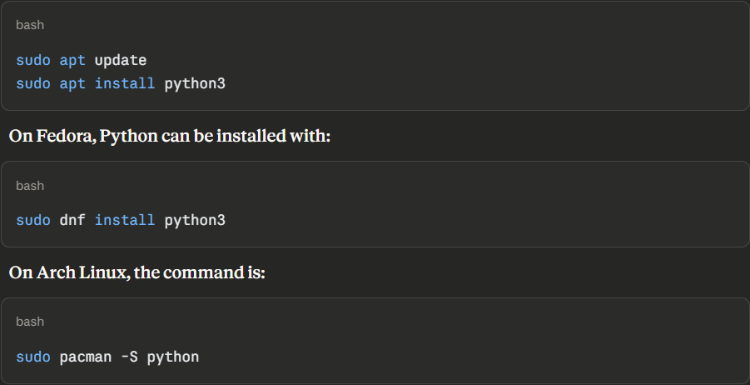
Python can also be compiled from source code downloaded from the official website of the Python Software Foundation at python.org.
After installation, Python stores its files in different directories across the Linux file system. The table below shows the most important locations:
Purpose | Directory
Main executable | /usr/bin/python3
Python libraries | /usr/lib/python3.x/
Documentation | /usr/share/doc/python3/
User-installed packages | ~/.local/lib/python3.x/
Package manager (pip) | /usr/bin/pip3

To confirm the installation path, the following command can be used:
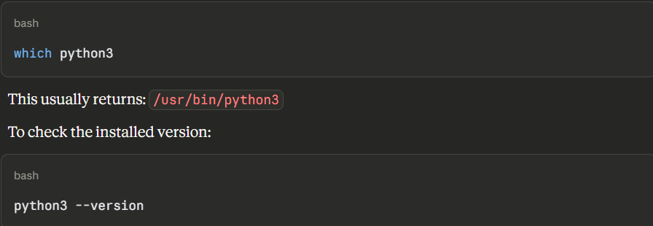
Understanding these directories is important because it shows how Linux organizes software in a structured way. Each directory has a purpose: binaries go in /usr/bin, libraries go in /usr/lib, and documentation goes in /usr/share/doc. This structure reflects the open and organized philosophy of Linux itself.
User and Group
Python itself does not run as a permanent background service like Apache or MySQL. Instead, it runs with the permissions of the currently logged-in user. For example, if the logged-in Linux user is "akshansh," then Python programs also run as akshansh. This is important because Linux security depends on user permissions. A normal user cannot modify important system files. Only a user with sudo access can do that.
If a Python-based application is deployed as a web service, it often runs under a separate system user such as www-data or a custom user like python-app. This reduces security risks by limiting what the program can access.
File Permissions
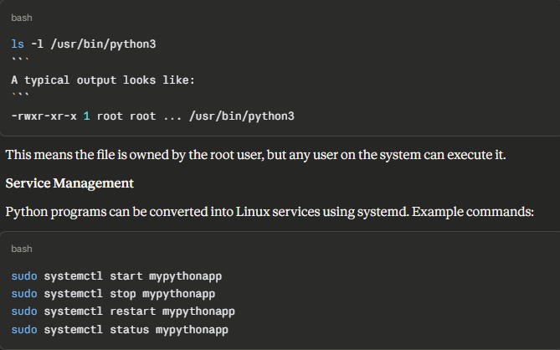
This allows Python-based applications to start automatically when the server boots, which is essential for production deployments.
Update Model
Python security updates are delivered through the Linux package manager. To update Python:
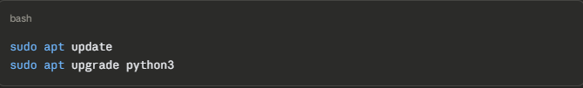
This is one of the major advantages of open-source software. The Python community regularly releases security patches and bug fixes. Linux users automatically receive these updates through official repositories without needing to manually visit a website or pay for a subscription.

PART C: DEPENDENCIES AND ECOSYSTEM
Python is not a standalone project. It depends on many other open-source tools and libraries to function correctly.
Core Dependencies:
- GCC compiler – used to compile Python's C extensions
- OpenSSL – provides encryption and secure communication support
- zlib – provides data compression support
- SQLite – provides built-in database support
- libffi – allows Python to call compiled C functions
- readline – improves the interactive terminal experience
Without these dependencies, Python cannot support encryption, databases, or interactive terminals. This shows that open source is not just about individual tools — it is an entire ecosystem where tools depend on each other.
Python's Own Package Ecosystem
Python also has its own massive package ecosystem. The main package manager is called pip, which stands for "Pip Installs Packages." Using pip, developers can install thousands of open-source libraries in seconds.
Examples:
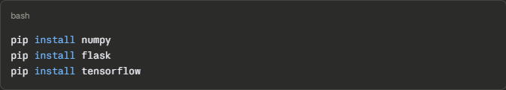Some of the most important Python libraries are:
Library | Purpose
NumPy | Mathematics and array operations
Pandas | Data analysis and manipulation
Flask | Lightweight web development framework
Django | Full-featured web development framework
TensorFlow | Artificial intelligence and deep learning
PyTorch | Deep learning research and development
Scikit-learn | Machine learning algorithms
Matplotlib | Data visualization and charting

These libraries make Python one of the most powerful and versatile programming languages in the world. A developer can build a web application, train a machine learning model, and analyze data — all using Python and its open-source ecosystem.
PYTHON COMMUNITY, GOVERNANCE, AND WEB ECOSYSTEM
What Python Has Enabled
Python has inspired and enabled entire industries. It is widely used in web development, data science, machine learning, scientific computing, and automation. Large companies such as Instagram, Spotify, and Dropbox have built major parts of their systems using Python. YouTube was originally built using Python. Google uses Python across many internal tools and systems.
Python and the Web
Traditional web servers often use the LAMP stack:
- Linux
- Apache
- MySQL
- PHP
However, many modern developers replace PHP with Python. A modern technology stack may look like:
- Linux
- Apache (or Nginx)
- MySQL (or PostgreSQL)
- Python (with Django or Flask)
Python web frameworks make development faster and more organized. Django provides a complete framework with built-in tools for authentication, database management, and security. Flask is a lighter framework that gives developers more control.
Community and Governance
Python has one of the strongest open-source communities in the world. The language is governed by the Python Software Foundation (PSF), a nonprofit organization that manages development, licensing, and community events.
The Python community includes:
- Online forums and Stack Overflow
- Official mailing lists
- GitHub repositories with thousands of contributors
- Local meetups around the world
- Global conferences such as PyCon, which is held in multiple countries every year
Because so many people contribute to Python, the language continues to improve every year. New features are proposed through a process called Python Enhancement Proposals (PEPs), which allows any community member to suggest changes. This democratic and transparent process is one of the reasons Python remains one of the most actively maintained open-source projects in the world.

PART D: OPEN SOURCE VS PROPRIETARY – PYTHON VS MATLAB
Python can be compared with MATLAB, which is a proprietary programming platform developed by MathWorks. Both are used in scientific computing and data analysis, but they represent very different philosophies.
Dimension | Python (Open Source) | MATLAB (Proprietary)
Cost | Completely free to download and use | Expensive paid license required
Security | Source code can be inspected by anyone | Source code is private and hidden
Support | Community forums, Stack Overflow, official documentation | Official company support from MathWorks
Freedom to Modify | Users can change the source code and contribute improvements | Users cannot modify the core software
Control | Managed by the Python Software Foundation and the community | Controlled entirely by one company
Learning | Easier for beginners, large number of free tutorials | More difficult and specialized, fewer free resources
AI and Data Science | Strong ecosystem with TensorFlow, PyTorch, NumPy, Pandas | Good numerical tools, but smaller AI ecosystem
Portability | Runs on Linux, Windows, macOS, embedded systems | Primarily desktop software
Community | Millions of developers worldwide | Smaller, mostly academic and engineering community

SHELL SCRIPT OUTPUTS
Script 1:
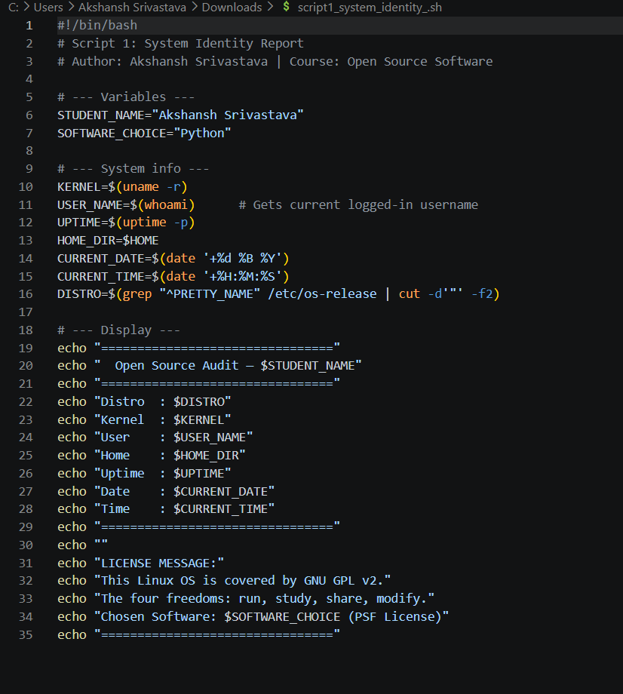
Output:
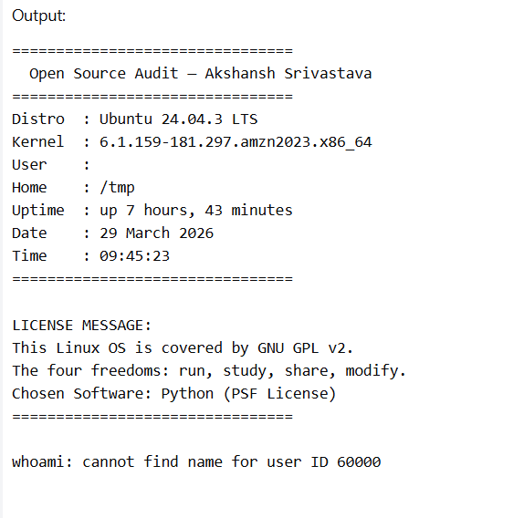

Script 2:
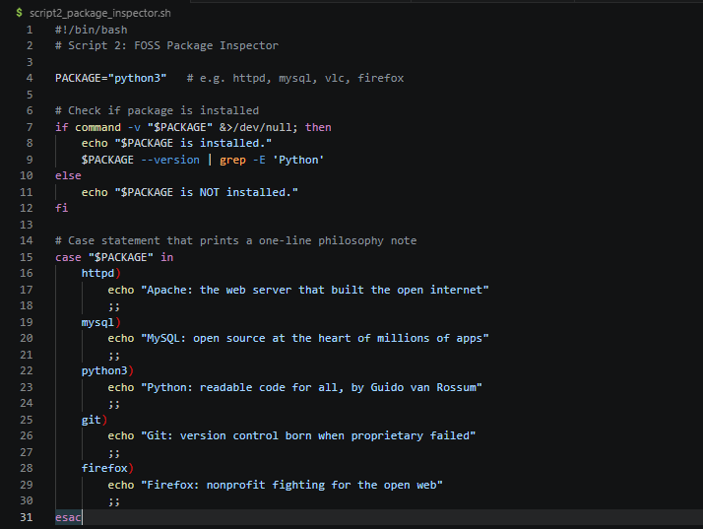

Output :
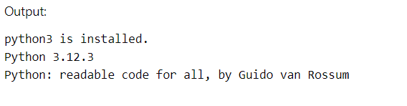

Script 3:
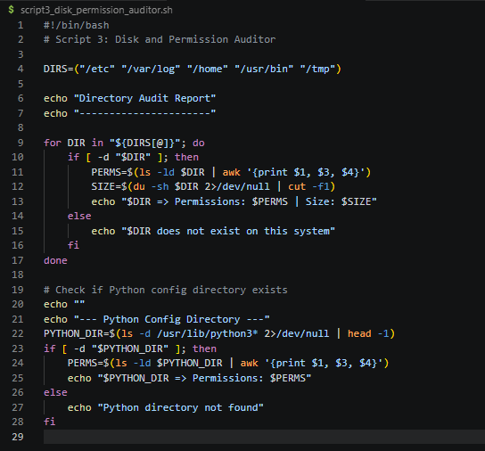

Output :
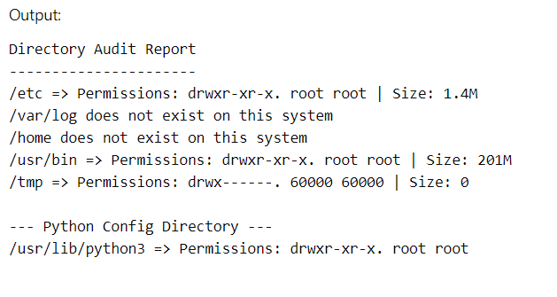

Script 4:
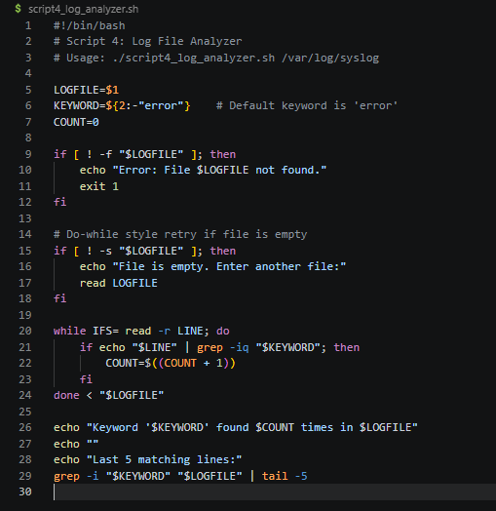
Output:
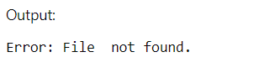

Script 5:
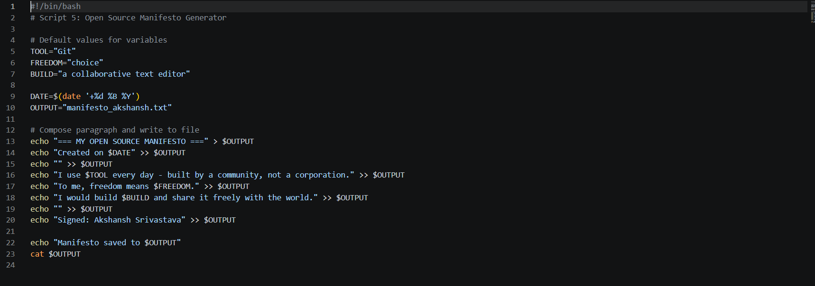
Output :
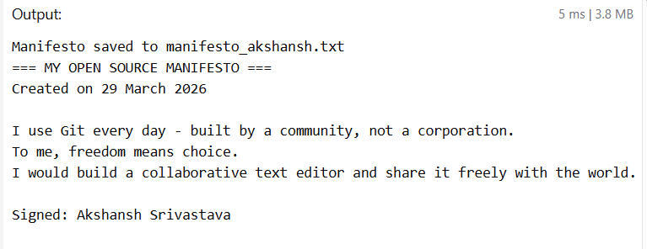

CONCLUSION
This project helped me understand that open source is not only about software — it is about freedom, collaboration, and the belief that knowledge should be shared.
Before doing this project, I knew Python only as a programming language that I used to write code. After researching its history, license, community, and Linux footprint, I now understand why Python became so successful and why it matters beyond just being a tool. Python was created because a programmer believed that technology should be accessible to everyone. That belief is still visible today in the way Python is licensed, maintained, and supported by a global community.
I also learned that open-source licenses are not just legal documents — they are statements of values. The difference between a GPL license and a PSF license reflects different beliefs about how software should be shared. Understanding these differences is important for anyone who plans to build software professionally.
The shell scripts taught me practical Linux skills, including working with variables, loops, conditions, file handling, and command-line arguments. These are skills that are directly useful in system administration, DevOps, and automation — fields where Linux and open-source tools are essential.
Most importantly, this project changed how I think about the software I use every day. Every tool I use — Python, Linux, Git, VS Code — was built by people who chose to share their work with the world. That is not something I will take for granted anymore.

REFERENCES
- Python Official Documentation – https://docs.python.org
- Python Software Foundation License – https://docs.python.org/3/license.html
- GNU Project – Free Software Definition – https://www.gnu.org/philosophy/free-sw.html
- Open Source Initiative – https://opensource.org
- Linux man pages – https://man7.org/linux/man-pages/
- Python Packaging Documentation – https://packaging.python.org
- Official Python GitHub Repository – https://github.com/python/cpython
- PyCon Official Website – https://pycon.org
- NumPy Documentation – https://numpy.org/doc
- TensorFlow Documentation – https://www.tensorflow.org

